|  |  |
| --- | --- |
| **Subject** | **Object Oriented Programming** |
| **Assignment** | **GUI (Application Form)** |
| **Submitted To** | **Sir Shahid Bhatti** |

**Submitted By:**

**Abeera Rehman SP24-BSE-005**

**________________________________________________________________**

**Section BSE-B**

**Key Features:**

1. **Banner Image:** Displays a static banner.jpeg image at the top of the form.
2. **Form Fields:**
   * Name
   * Father's Name
   * CNIC
   * Date Picker for the date of birth
   * Radio buttons for gender selection (Male/Female)
   * Dropdown (ComboBox) for selecting the city
3. **Image Upload:**
   * Allows the user to select and display a profile image via a FileChooser.
4. **Save Functionality:**
   * Collects and validates form inputs.
   * Ensures no field is left empty before saving.
   * Saves form data in a List<Person> for further use.
   * Displays a success message upon saving or an error message if fields are incomplete.
5. **Reset Form:**
   * Clears all input fields after the data is successfully saved.

.

**Code Structure:**

* **ApplicationForm:** Main class containing the UI setup and event handling logic.
* **Person Class:** Represents the form data structure with attributes such as name, father's name, CNIC, date, gender, and city.

**OUTPUTS:**

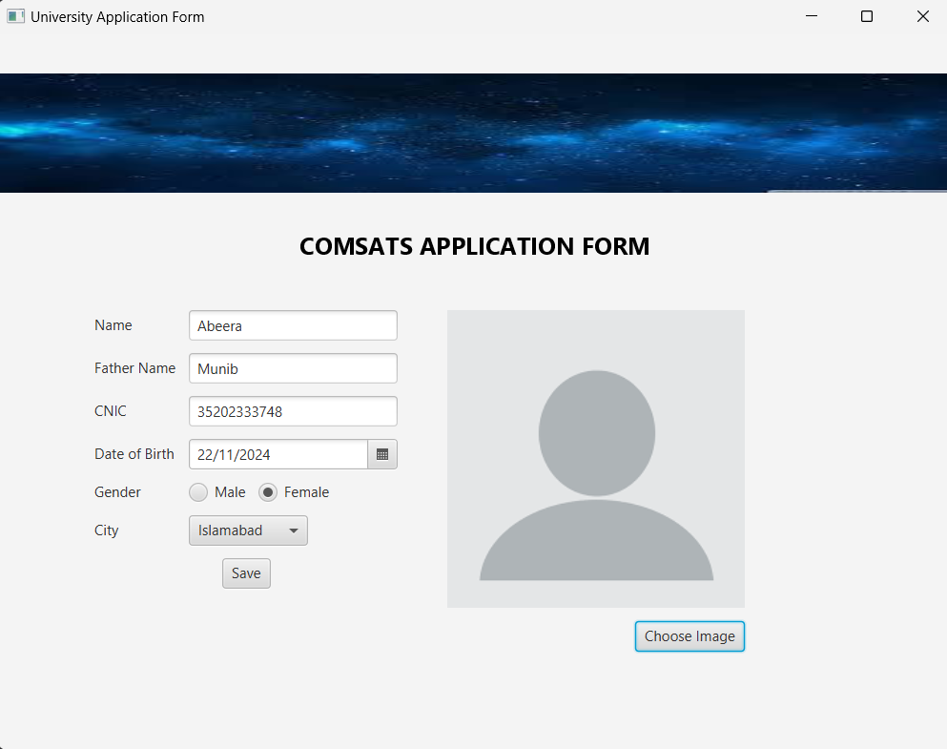**First user enters the data:**

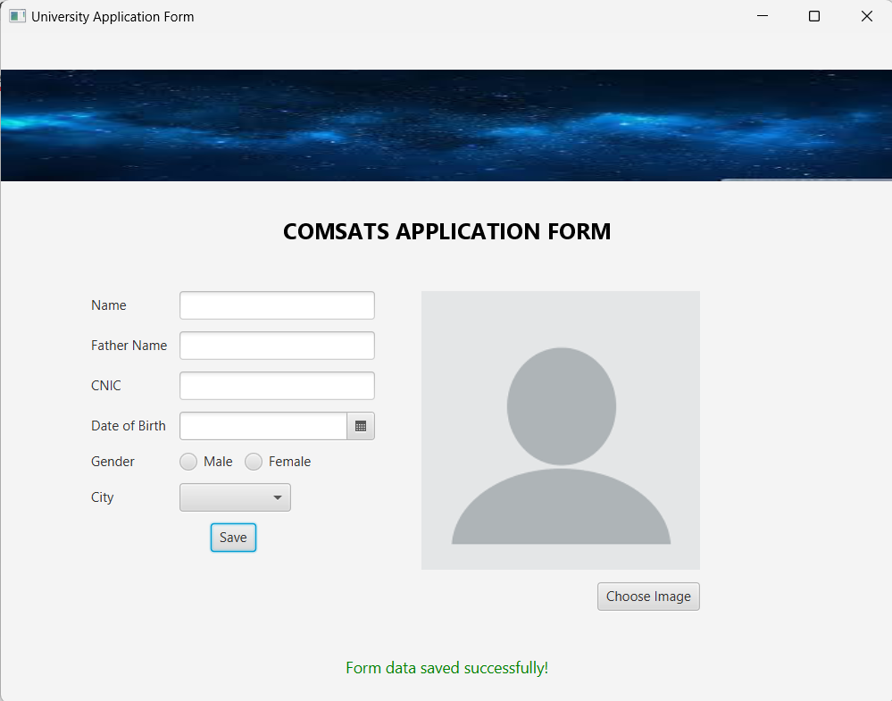**Upon successful completion of form:**

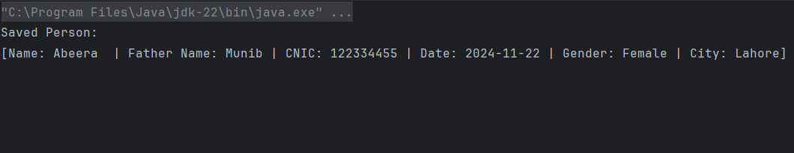**Data is printed in console upon successful completion**

**Upon unsuccessful completion it displays a message to fill all fields**



